**KNOWLEDGE ORGANISER**

The ancient Kingdom of Benin: AD 900 to 1900

|  |
| --- |
| Location |
| West Africa. Benin City in the west of Nigeria is the location of the ancient Kingdom of Benin.  It is NOT located in Benin found on modern maps – this is a different country in Africa. |

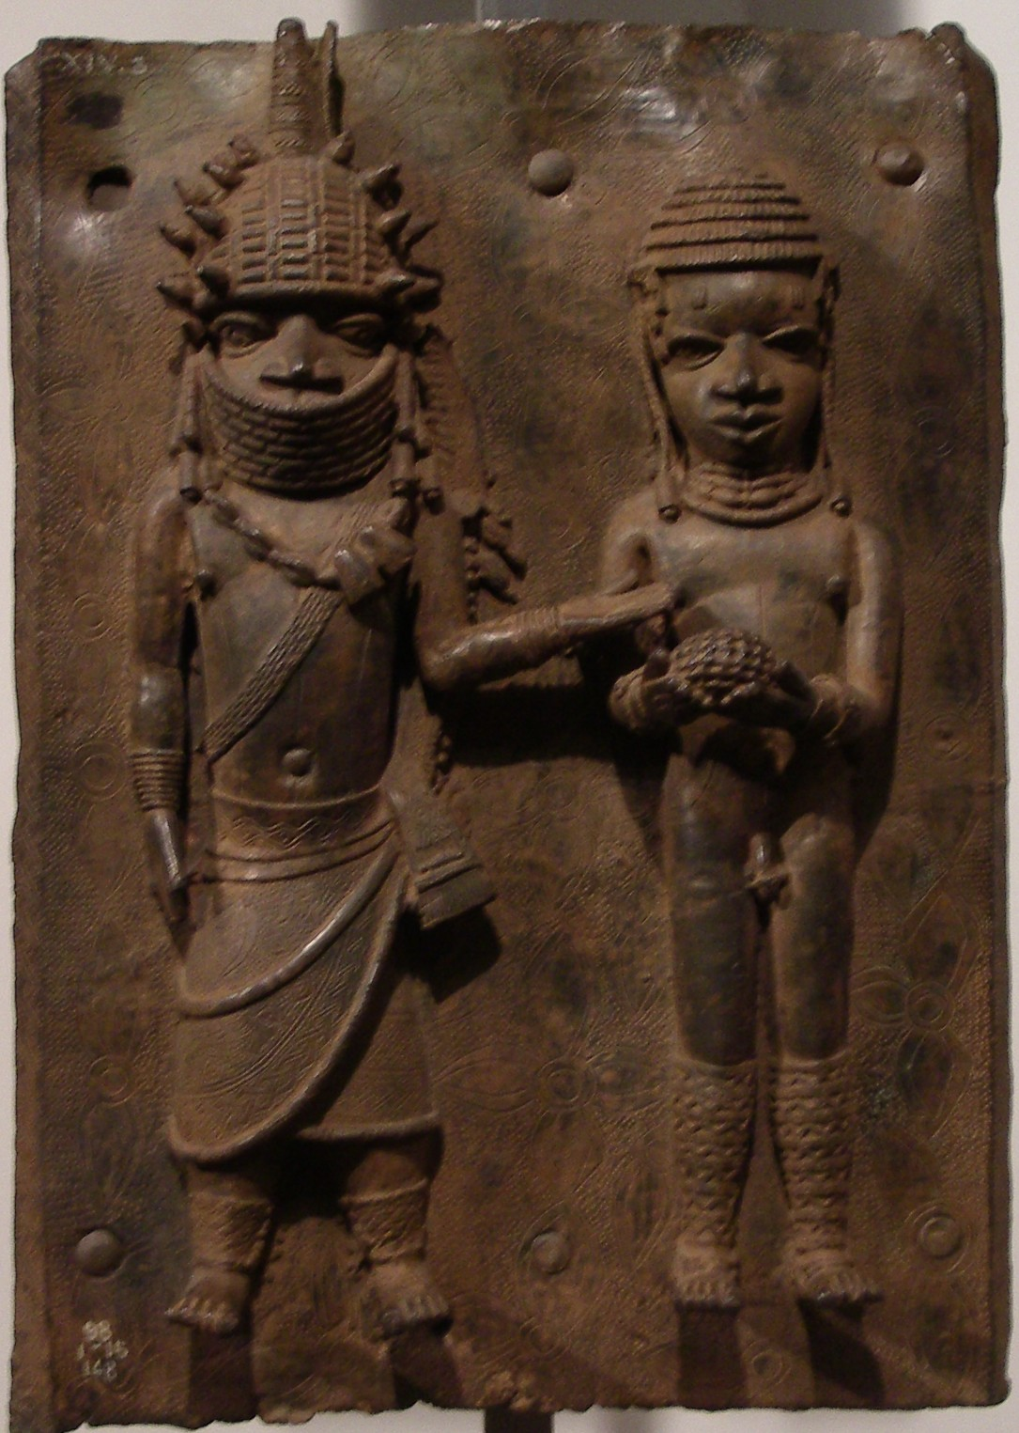 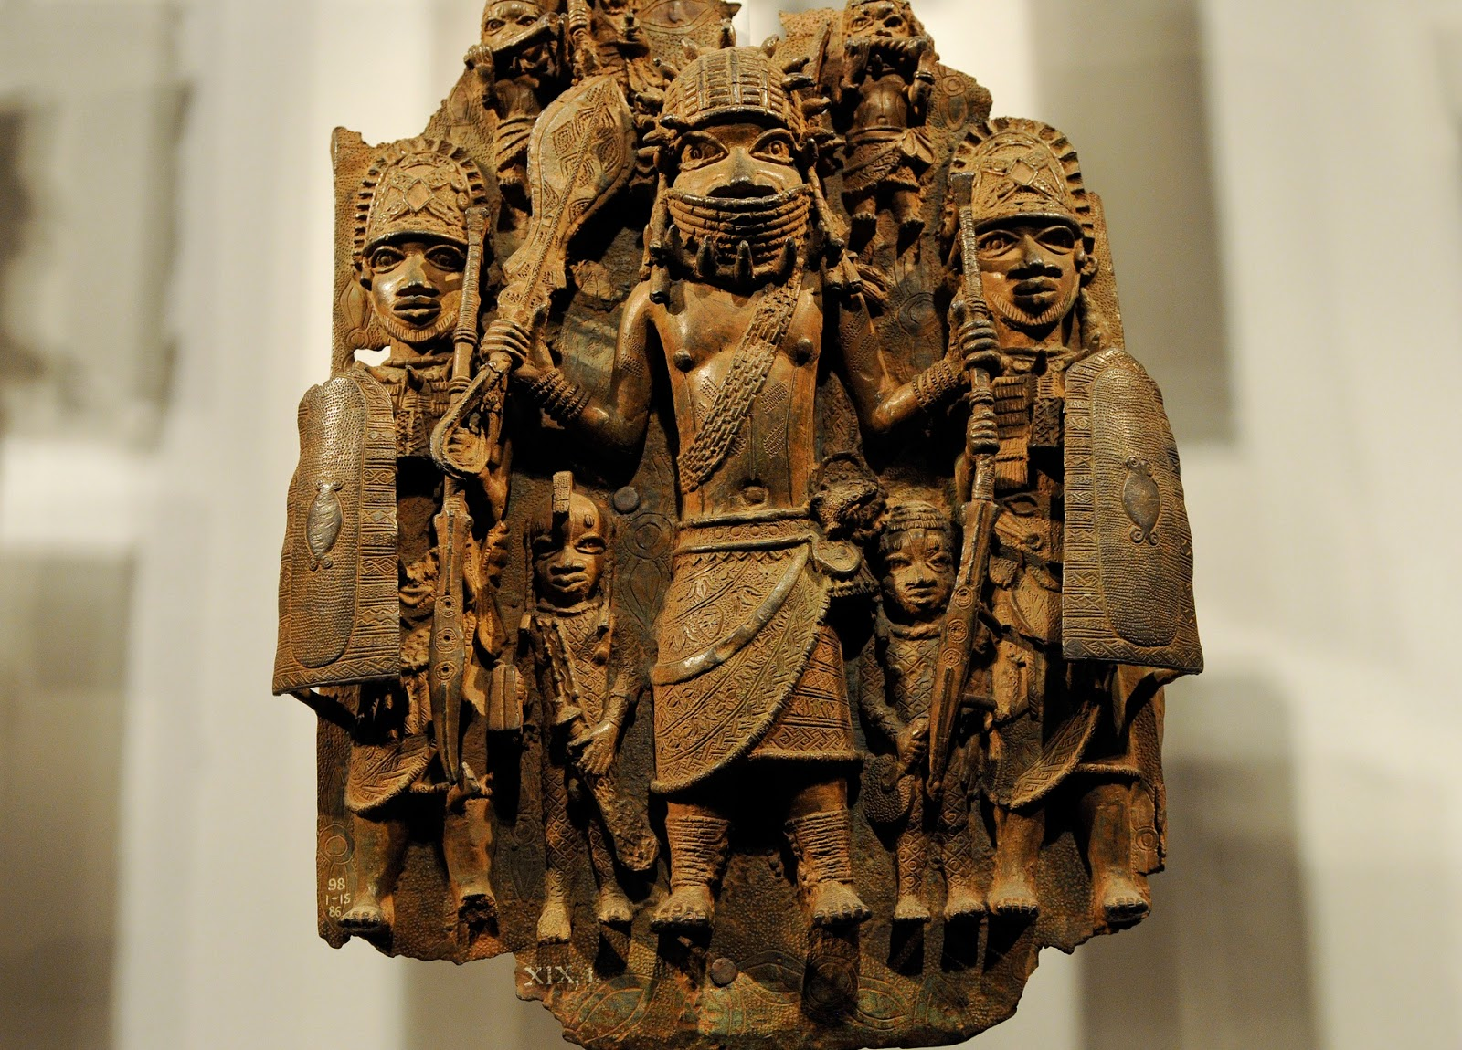 

|  |  |
| --- | --- |
| The three main periods (all AD) | |
| 900 - 1300 | Early Period |
| 1300 – 1700 | The Golden Age |
| 1700 – 1897 | The Period of Decline |

|  |  |
| --- | --- |
| Key individuals |  |
| Ogiso Igodo | The first king of Benin. |
| Ogiso Owodo | The last of the Ogiso kings. |
| Oba Eweka | The first of a new dynasty of kings called the Obas, crowned around 1200. |
| Oba Oguole | Had the Benin City Wall built 1283. |
| Oba Ewuare | Expanded the kingdom greatly and set up trading links with Portugal in 1514. |
| Oba Ovonramwen | The last king of Benin, exiled by British troops after their invasion in 1897. |

|  |
| --- |
| Key vocabulary |
| Animism = A belief that the Benin people had, that nonhuman objects had spirits.  Cowrie shells = Currency (above) for trading  British Empire = After 1897 Benin became part of the British Empire (Being ruled by Britain)  Benin bronzes = Artwork (above) created by skilled Benin craftsmen.  Colony = A country ruled by another.  Earthen moat = A man made moat that went around the boundary of the Benin empire, which was four times as large as the Great Wall of China.  Oba = the ruler of Benin  Ogisos = Kings of Benin before the Obas  Yoruba Peppers = One of the main items the people of Benin traded.   * Ivory |

|  |  |
| --- | --- |
| Timeline of key events | |
| 900 | Benin Kingdom is first established when small villages join together in a conglomerate. |
| 900 – 1400 | An enormous earthen moat is built around the Kingdom boundaries. |
| 1200 | The first dynasty of Ogiso kings ends and the Obas begin their rule with Eweka I. |
| 1440 | Benin begins to expand and thrive under the rule of Oba Ewuare the Great. |
| 1514 | Oba Esigie sets up trading links with Portuguese and other European visitors. |
| 1700 | Benin Kingdom enters a period of decline due to a series of civil wars and the abolition of the slave trade with Europe. |
| 1897 | Benin City is destroyed by British troops and Benin comes under Britain’s control. |

Spare information

|  |
| --- |
| The people of Benin |
| Most sources tell us about the rich and powerful people in Benin. Little is known about the ordinary men, women and children.  Historians believe that **most** people:   * were farmers, growing crops like yams and plantains or clearing vast areas of communal land; • had two or three different jobs * may have been part of one of the guilds of craftsmen producing goods for trade. They believe others may have been: * warriors; * entertainers; • builders.   Women were responsible for:   * looking after their families; * making domestic objects such as cooking pots.   Children:   * did not go to school but learned each day from storytellers. |
| Extra information |
| * Storytellers were very important and kept the kingdom’s history and mythology alive by telling stories aloud by the fire every evening. * The people of Benin had many stories involving gods and magic and they believed that nonhuman objects had spirits or souls, a belief known as ‘animism’. * The builders of Benin made an **earthen moat** around their kingdom – this is 4 times as large as the Great Wall of China but was destroyed by British soldiers. * The famous **Benin bronzes** are now located around the world in museums and with collectors.   Nigeria is asking for their repatriation (return to the country of origin). |