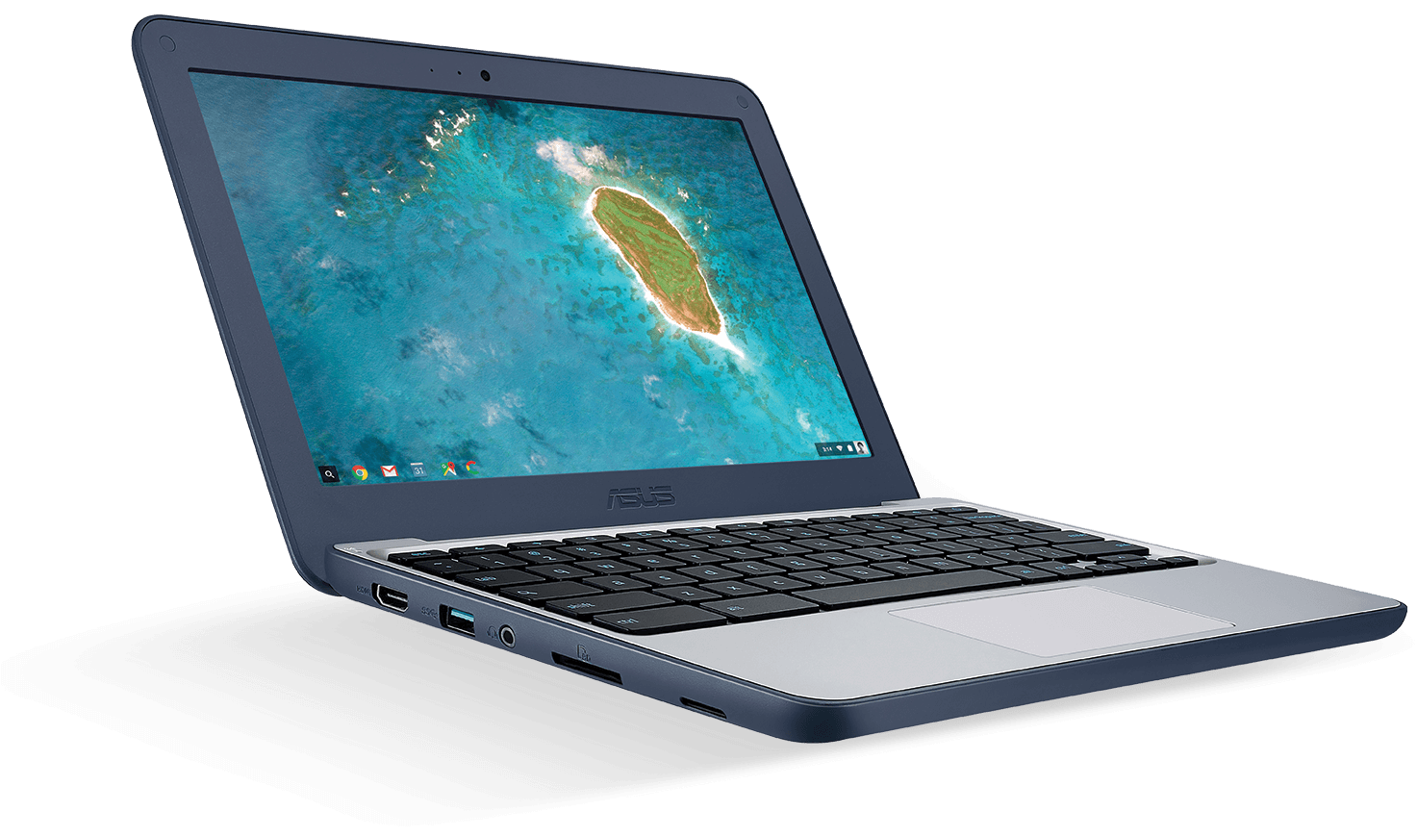
The Chromebook bundle:

- 11.6” ruggedised ASUS Chromebook C202SA, Intel® Celeron® Dual-Core N3060, 4G / 16G eMMC
- Management License - The school will be managing these devices for students
- Complete accidental damage and theft insurance, zero excess - over the term of the donations.

We have the following suggested donations for the bundle above:
Year 5/6 from this September
30 months of £10.00 collected monthly, 30 x £10.00 = £300.00
Year 7 from this September
24 months of £12.00 collected monthly, 24 x £12.00 = £288.0
Year 8 from this September
12 months of £21.50 collected monthly, 12 x £21.50 = £258.00
AFTER ALL PAYMENTS ARE MADE THE CHROMEBOOK BECOMES YOURS TO KEEP
Declaration of interest
Please follow the link below and complete the attached form to indicate if you would be prepared to support this scheme. (All submissions are anonymous.)
Form for iphone users: https://tinyurl.com/yb6gqgky
Or
Form for android users : https://docs.google.com/forms/d/e/1FAIpQLSfPX7b_mEozo2p7jBe4BLyWbDh3kXvHCb0O4TfuOiO4eMZW3w/viewform (ANDROID USER)

