
Our Ref. CW/AE/jp

8th November 2021

Dear Parent/Carer,

Magistrates’ Court Mock Trial Competition – Participation Permission

Young Citizens is an independent charity which helps young people to engage with their community through education. It runs a national active learning project called the Magistrates’ Court Mock Trial Competition. Our Year 8’s at St John’s have participated successfully in this for many years.

The Competition involves a team of students taking on the roles of magistrates, lawyers, witnesses and court staff to prepare a specially written case. Schools compete against each other in a live format at a real magistrates’ court.

We are pleased to inform you that your child has signed up to be selected as a member of the team for our participation in the Worcester local heat.

In order to prepare for the heat, the team will meet once a week every Tuesday at 3:30p.m. until 4:30p.m. in Room 5. Your child must be committed to attending these workshops and able to participate in the heat on Saturday 19th March 2022 from 9:00a.m. until approximately 2:00p.m. The first workshop will start this week, on Tuesday 9th November.

If you would like your child to attend these workshops and to take part in the competition, including being in attendance at court on the day in question please complete the permission notice located in the Parentmail Forms section, as soon as possible.

Thank you for supporting your child and the school in this activity.
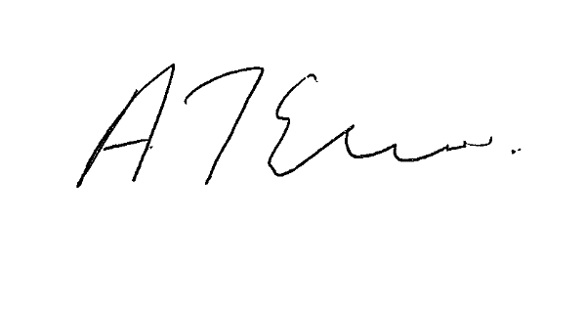
Yours faithfully,

C. Woodward

Mrs C Woodward Mrs A Elwell
Co-ordinating Teacher Head of School
______________________________________________________________

