TRANSITION TO MIDDLE SCHOOL

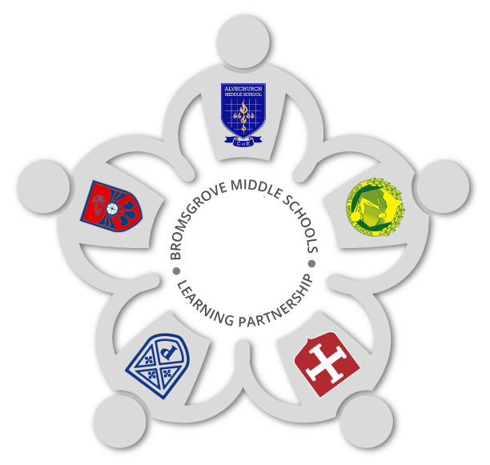
Name: ________________________________________________

My First School: ______________________________________

My Middle School: ____________________________________

September 2021
Introduction.

This booklet is to help you start thinking about moving up to middle school. It will help you think about things you do or enjoy in school, think about how you feel about middle school as well as help your new teacher to learn a bit about you.

You can even start to think about any questions you might have and if you like, include some work you want to show your new teacher.

Have fun and just fill in whatever you can, then bring your booklet into your new middle school with you.

All About Me
Me
My name is:
I like to be called:
My friends are:

My family members are:

My pets are:

My hobbies are:

My favourite lessons are:

The things I struggle with or do not like are:

At first school I really liked:

People who helped me at first school were:

Things I got involved with at First School were:

Things I am proud of:

Choose some work from year 4 or work you might have available that you have done at home that you are really proud of and want to share with your new middle school teachers.

Try to include:
- A piece of writing
- A piece of maths
- A science investigation

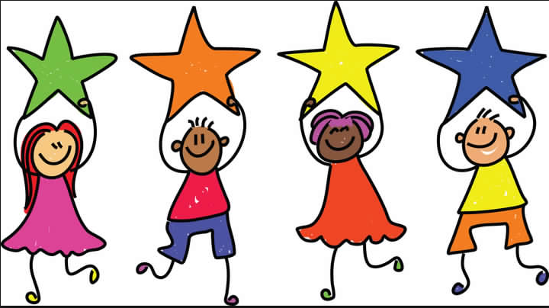

Getting ready for Middle School
The way I learn best is…

In my new Middle School, I would like to join in….

It is natural to have a mixture of feelings when changing schools. My feelings about starting Middle School.
I am excited about:

I am nervous about:

Questions and Answers:
Before I start Middle School, I want to find out:

To be completed on Induction Day.
The answers to my questions:

Induction Day Thoughts
Today, I met new teachers. They are called:
______________________________________________________________________________________________
Today, I really enjoyed:
_____________________________________________________________________________________________________________________________________________
New friends I have met:
_____________________________________________________________________________________________________________________________________________
I am now looking forward to:
_____________________________________________________________________________________________________________________________________________

Well done, you have completed your induction to
Middle School.
We look forward to seeing you in September.

