22.6.20 | Morning Session | Afternoon Session
Monday | 9.00am – Movement/ PE time Joe Wick Live PE workout. https://www.youtube.com/channel/UCAxW1XT0iEJo0TYlRfn6rYQ  10.00am – Spellings Practice  10.15am – Maths – Continue to work through the tasks set on Epraise using My Maths and supplemented by White Rose Learning. You also need to complete this week’s Arithmetic test on a day of your choice.  11:15 – English Oak Academy Lesson 5 – Diary Entry: Write a Diary Entry Lunch Break | Complete one of the foundation subject tasks on the following page.  30 Minutes Reading  Reading Challenge: Design an original Book cover for your book.
Tuesday | 9.00am – Movement/ PE time – Virtual Schools Games Challenge – agility running challenge. Submit your scores online to be in with a chance of winning and to receive your e-certificate. https://www.activehw.co.uk/worcestershire-school-games  10.00am – Spellings Practice  10.15am – Maths Continue to work through the tasks set on Epraise using My Maths and supplemented by White Rose Learning. You also need to complete this week’s Arithmetic test on a day of your choice.  11:15 – English Oak Academy Lesson 1 – Set of Instructions: Reading Comprehension (Language)  Lunch Break | Science – Mr Owen’s Group – Research Task on the Life of Charles Darwin. Ms Jarvis, Miss Shaw & Mr Hill’s Groups – Use your research on Mary Anning to complete the Mary Anning Activity Sheet  30 Minutes Reading  Reading Challenge: Recap a chapter you have read as a story board.
Wednesday | 9.00am – Movement/ PE time Joe Wick Live PE workout. https://www.youtube.com/channel/UCAxW1XT0iEJo0TYlRfn6rYQ  10.00am – Spellings Practice  10.15am – Maths Continue to work through the tasks set on Epraise using My Maths and supplemented by White Rose Learning. You also need to complete this week’s Arithmetic test on a day of your choice.  11:15 – English Oak Academy Lesson 2 – Set of Instructions: Reading Comprehension (Word Meaning)  Lunch Break | Complete one of the foundation subject tasks on the following page.  30 Minutes Reading  Reading Challenge: Write a new blurb for your book.
Thursday | 9am Movement/ PE Week 10 PE challenges. Find on Epraise or School website. Submit your scores to your PE teacher via E-praise.  10.00am – Spellings Practice  10.15am – Maths Continue to work through the tasks set on Epraise using My Maths and supplemented by White Rose Learning. You also need to complete this week’s Arithmetic test on a day of your choice.  11:15 – English Oak Academy Lesson 3 – Set of Instructions: Identifying the Features of a Text  Lunch Break | Science Mr Owen’s Group – Finish your Darwin Research Task. Ms Jarvis, Miss Shaw & Mr Hill’s Groups – Finish the Mary Anning Activity Sheet  30 Minutes Reading  Reading Challenge: Identify 10 words in your book and look up the definition.
Friday | 9am. – Yoga for Teens https://m.youtube.com/watch?v=7kgZnJqzNaU Once you have done this workout. Research 10 of your own yoga moves to create your own yoga flow. Hold each of your poses for 15 seconds and repeat 3 times.  10.00am – Spellings Test! Ask somebody to test you on this week’s spelling – how many can you get correct?  10.15am – Maths Continue to work through the tasks set on Epraise using My Maths and supplemented by White Rose Learning. You also need to complete this week’s Arithmetic test on a day of your choice.  Complete this week’s Collective Worship activity on the next page. | Complete two of the foundation subject tasks on the following page.  30 Minutes Reading  Reading Challenge: Read a non-fiction text and create a poster of what you learnt.
Year 5 Home Learning Timetable
 | Foundation Subject task
Art | 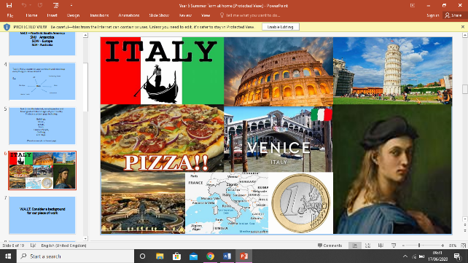  For Art we would like you to continue with the project your Art teacher has set for you on Epraise.Take your time to complete tasks between now and the summer break. You can also find the Art Project power points on our school website under Home Learning.For those of you who have completed this,your Art teacher will be sending you a new keyboard task to complete – you can find this in the home learning section of the school website.
French | The theme of your French lesson this week is food. Work through the French power point to learn and practice talking about food types in French. You will find this set as homework on Epraise or on the school website. Bon Appetit!  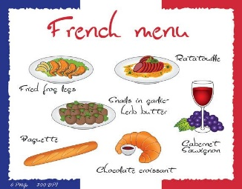
Geography | Complete the work set by your Geography teacher on environmental change. Go to Epraise to find this activity and an extension.
Computing | For computing we would like you to continue working through your scratch projects at your own speed. Here is the link you need if you haven’t started. These activities cover some of our summer term objectives and will give you a head start when we return to school. If you would like an extension or challenge, please send an Epriase message to Miss Jarvis.  https://projects.raspberrypi.org/en/codeclub/scratch-module-1
Collective Worship
HOPE: “And this hope will never disappoint us. We know this because God has poured out his love to fill our hearts through the Holy Spirit he gave us.” Romans 5:5
READ: The Story of Queen Esther - 'For Such a Time as This'
https://www.assemblies.org.uk/pri/3288/hope-in-a-hard-place
REFLECTION: Using a piece of A4 paper, draw the person/thing that most gives you hope.

Year 2 Spellings

Year 5 Spellings
On the next page you will see some spellings that we would like you to work on this week. Each day we would like you to spend at least 15 minutes practicing your spellings. As well as copying out the sentences below or completing the sheet, on the website you will find a spellings document named ‘Spellings fun! Activity sheet’. Each day choose a worksheet to complete using the spellings on the next page. On Friday ask somebody else to test you and see how many you can get right.

Y5 Spellings: Homophones (1)
Use the words from the box below to complete these sentences.
You may only use each word once. Tick off each word as you use it.
wear | past | precedes
where | passed | proceed
led | morning
lead | mourning
1. | You must _________________ your school uniform on the trip.
2. | I drove _________________ my friend’s house this morning.
3. | You may _________________ to the start line of the racetrack.
4. | I don’t know _________________ my school shoes are.
5. | I _________________ my piano exam last Saturday.
6. | I _________________our class out onto the playground at breaktime.
7. | Yesterday _________________, we had an assembly.
8. | Queen Victoria went into _________________ when her husband died.
9. | My first name _________________ my surname.
10. | Pencils used to be made of _________________, which was poisonous.

Once you have completed this sheet look on the website for the ‘Spelling Fun! Activity worksheet” and complete at least one worksheet each day. Don’t worry if you cannot print them, just complete the task on paper or in a notebook.
Now that you know the meanings of these words, you need to practise spelling them correctly! Complete this activity on the back of this sheet:

Spelling Scramble:
Write out 6 spelling words but scramble them up. Wait until the next day to unscramble the words ensuring you know how to spell them correctly
For example: ‘ampexel’ is scrambled up but unscrambled, the word is ‘example’.

