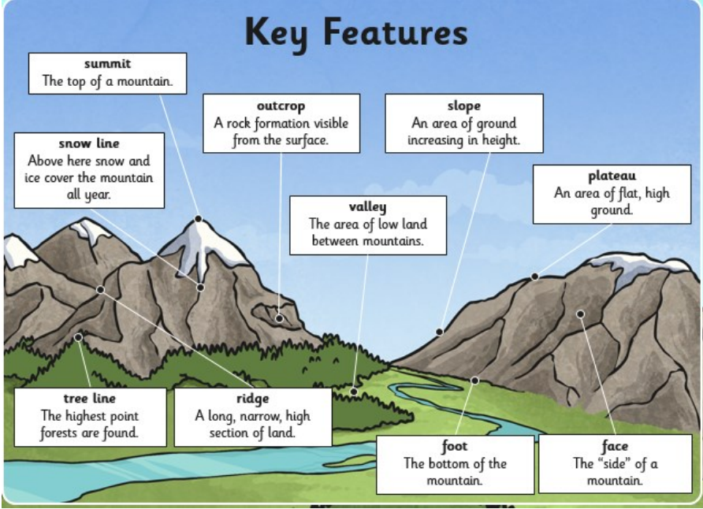

Y5 Mountains Knowledge Organiser

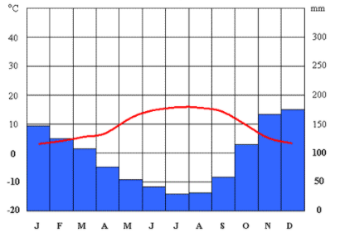

A climate graph shows the average monthly rainfall and temperature of a place. This helps us to understand the mountain environment and when it is best to visit mountainous areas.

Climate Graphs

Mountains Keywords

* Rural Snowdonia
* urban height
* environments index
* forests Ben Nevis
* Mountain peak Avalanche
* mountain range crevasse
* atlas ice
* glossary freezing
* snow hole Snowdon
* Mountain Rescue Fundraise
* Volunteer label
* helicopter axis
* Compass temperature
* Falls Rainfall
* Weather Scafell Pike
* Three Peaks Challenge Climate graph

Highest Peaks in World

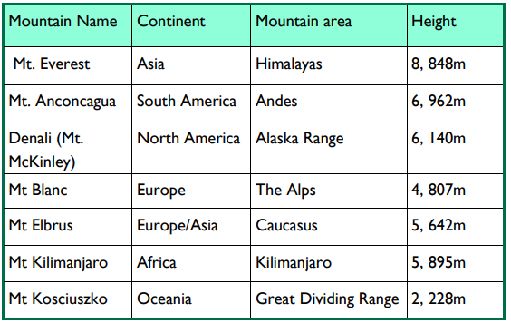

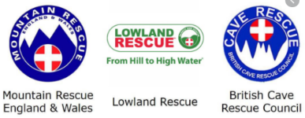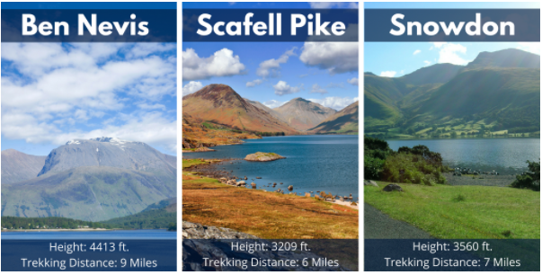

**Who helps us in the mountains if we get into trouble?**

*“The beautiful, yet deadly mountaintop rose out of the mist like a shining white whale, breaking the surface of the deep green ocean.”*

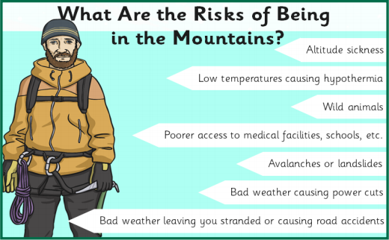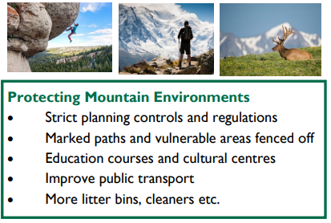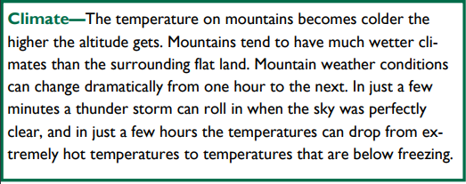

**More dangers in the mountains:**

* Crevasses
* Landslides and rockfalls
* Trips and falls
* Becoming lost

**Mountain climate**

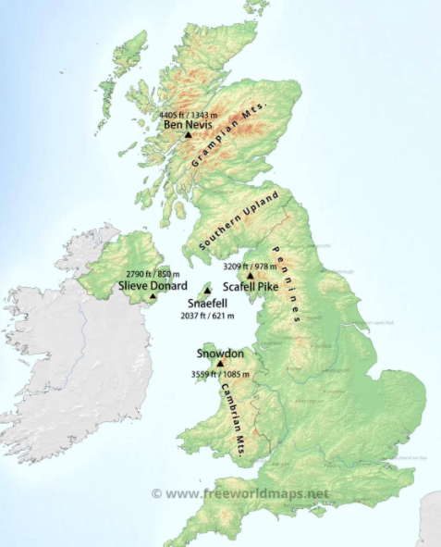

Highest Peaks in the UK