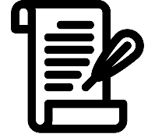
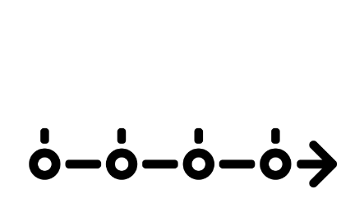
KNOWLEDGE ORGANISER
What does studying History involve?

Key word | Definition
Cause | The reason why something has happened.
Consequence | The result of an event.
Change | When something becomes different. Change can be positive or negative, progress or regress.
Continuity | When things stay the same or continue as they were e.g. ideas about the causes of disease did not change much from the Romans to early modern period.
Source | A piece of evidence used in history to help us learn about the past.
Reliability | How trustworthy a source is. We judge this by looking at when it was made, where it was made, and who made it as well as what it tells us. However, even if a source is unreliable, it can still be useful.
Utility | How useful a source is to you or a historian. We judge this by looking at what the source says and how far it supports what we already know.
Chronological order | Putting dates and events in the order in which they happened, from the oldest to the youngest, the first to the last.
Significance | The idea that an event or person is extremely important within the time period we are studying. We use criteria such as the 5R’s or short term and long-term impact to assess significance.
Timeline | A diagram used to put dates in chronological order.
BCE/BC | Dates with BCE beside them are from “before the common era”. Dates with BCE beside them count upwards to 0. E.g. on a timeline 400BCE would come before 50BCE because it happened first. BCE and BC are the same thing. BC means “before Christ”. This is because history in Europe was written mostly by monks and controlled by the Catholic Church and so events were dated as happening either before or after Christ.
CE/AD | Dates with CE beside them stand for “the common era”. Dates with CE beside them count upwards from 0. E.g. 1066CE would come before 2018CE on a timeline because it happened first. AD is the same as CE. AD means “anno domini”, translating to ‘in the year of our lord’.
Decade | 10 years
Century | 100 years. When we talk about centuries e.g. the 19th century we are referring to the years 1800-1899. This is because the 1st century starts at 0 and ends in the year 99.
Millennium | 1000 years
Primary evidence | Evidence from the time period you are studying, such as a diary.
Secondary evidence | Evidence that was produced after the time period you are studying i.e. a modern film.
Family tree | A diagram showing the relationships between people in several generations of a family.
Where does our information come from in history lessons?

Interpretations
In history lesson we often use extracts from historians known as interpretations. This shows us the historian’s opinion of the event, time period or person. We often compare two historian’s interpretations to see how opinions can vary and also change over time.
Sources
A source is a piece of evidence that we use to help us learn about the past. Primary sources come from the time we are studying, for example, a manuscript from ancient Egypt. Secondary sources are made after the time we are studying, for example, a textbook about the ancient Egyptians.

Key areas to research Important concepts
What have you found out about:  The Tollund Man?  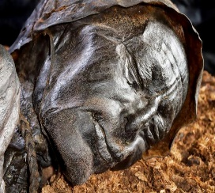  This Photo by Unknown Author is licensed under CC BY-NC-ND  Your Family tree?  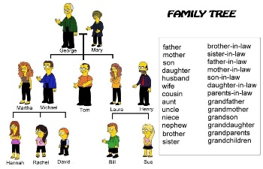  This Photo by Unknown Author is licensed under CC BY-SA-NC | Utility  When we use sources we have to consider how useful they can be to us. A source is useful to us if it helps us understand more about the time period and supports information that we already know.  ALL SOURCES ARE USEFUL. Even if the information is one sided or unreliable, it can still show us how people were thinking and feeling at the time and lead us to ask questions about why this may have been the case.  Historians  A historian is someone who researches and investigates the past. They look at a range of sources to help come up with their interpretation of history.  Interpretations  When we look at events in history, we often look at how they have been viewed by people over time. This is called interpretation. It is someone’s “take” on history.

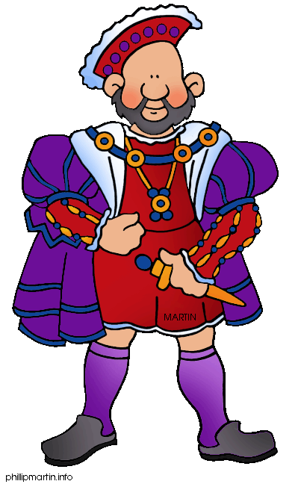
1325 BCE– King Tutankhamun was buried in the Valley of Kings
30 BCE – Queen Cleopatra died, signaling the end of Ancient Egypt
471 CE – The fall of the Roman Empire
1066CE – The Normans invade Britain
1509CE – Henry VIII becomes king of England
1861CE – Louis Pasteur discovers gems
1969CE – Man walks on the moon
Example timeline

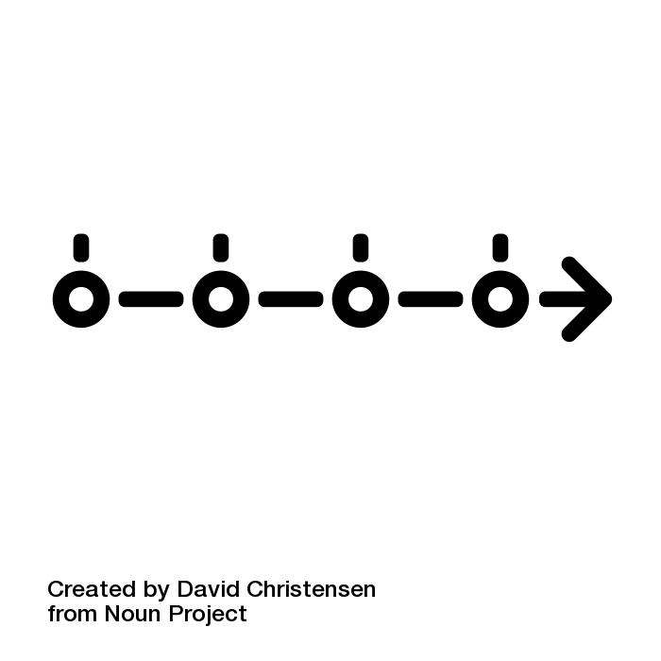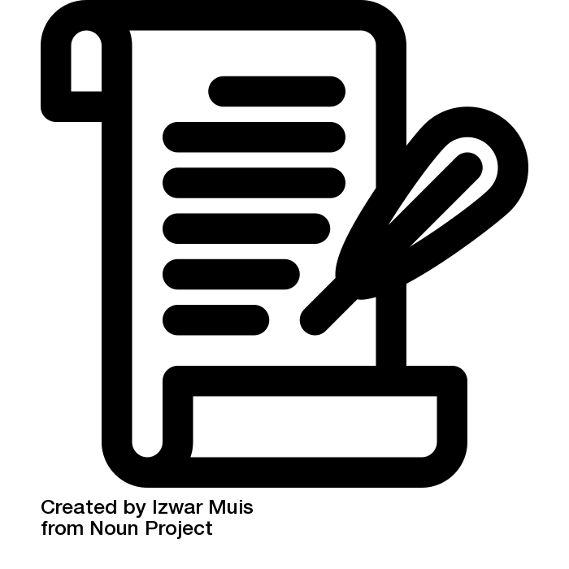
Image attribution

