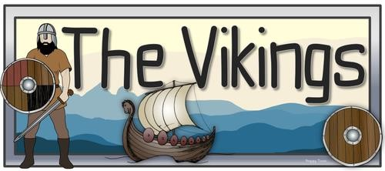
St Johns Middle School Academy Knowledge Organiser Year 6 Autumn term 1: were the Vikings ever civil?
Where did the Vikings settle in Britain? | What happened to the Vikings? | Key Dates
Danelaw covered an area east of their line joining London and Chester. Everything to the east belonged to the Vikings.  There were three main areas where Vikings lived -  Northumbria (which included modern-day Yorkshire), East Anglia, and the Five Boroughs. A borough was a town and the five towns were Leicester, Nottingham, Derby, Stamford and Lincoln.  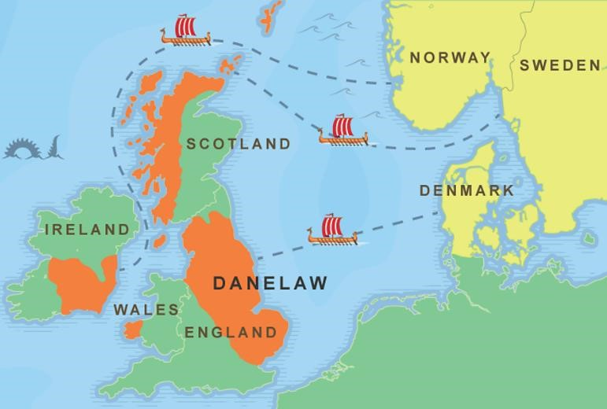  Viking families came to settle on these lands. Good farmland was scarce in the Vikings' own countries, and they were looking for a better life. | English kings gradually recaptured more and more land from the Vikings.  Alfred's son Edward fought for control of the Danelaw and Alfred's grandson, Athelstan, pushed English power north as far as Scotland.  In 954, the Anglo-Saxons drove out Eric Bloodaxe, the last Viking king of Jorvik. Later, when Eric was killed in battle, the Vikings agreed to be ruled by England's king.  In the early 11th century, England had a weak king. His name was Ethelred the Unready. Ethelred tried to stop the Vikings from invading by giving them gold and land. This money was called Danegeld. But it didn’t work – the Vikings took the gold and attacked anyway.  In 1002, Ethelred's soldiers killed many Viking families in the Danelaw. This made King Sweyn of Denmark angry. He invaded England and Ethelred had to flee to France. | 793  829 | Vikings attack Lindisfarne  Wessex becomes the Supreme Kingdom
 |  | 851 | Athelstan, son of the king of Wessex, defeats a  Viking fleet in battle
 |  | 866 - 77 | Invasion of the Great Danish (Viking) Army (Great Heathen Army
 |  | 867 | The Vikings kill rival kings of Northumbria and capture York – The city becomes Jorvik, the Viking capital in England
 |  | 878 | Wessex is overrun by Vikings and King Alfred goes into hiding
 |  | 886 | Treaty of Wedmore England is divided – The Saxons retain the west, while the east was to be Viking territory - later known as the 'Danelaw' - where the English and Vikings were equal in law.
 |  | 926 | Eastern England is conquered by the Saxons
 |  | 927 | Athelstan, king of Wessex, takes York from the  Vikings
 |  | 939 | Athelstan, first king of all England dies
 |  | 954 | Eric Bloodaxe, the last Viking king in England, is forced out of Jorvik (York)

